Sort these rocks into groups depending on whether they were man-made or natural rocks.
brick | granite | limestone
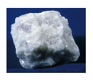 | 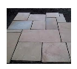
marble | concrete slab | slate

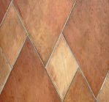
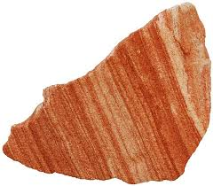
sandstone ceramic tiles

Man made rocks | Natural rocks
___________________________________  ___________________________________  ___________________________________ | ___________________________________  ___________________________________  ___________________________________

